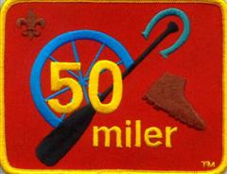

50 Miler Award

The 50-Miler Award is presented to each qualifying individual for satisfactory participation in an approved trip. In order to qualify for the award the group of which the individual is a member must fulfill all of the following requirements.
- Make complete and satisfactory plans for the trip, including the possibilities of advancement.
- Cover the trail or canoe or boat route of not less than 50 consecutive miles; take a minimum of 5 consecutive days to complete the trip without the aid of motors. (In some areas pack animals may be used.)
- During the time on the trail or waterway, complete a minimum of 10 hours each of group work on projects to improve the trail, springs, campsite, portage or area. If after checking with recognized authorities, it is not possible to complete 10 hours each of group work on the trail, a similar project may be done in the unit's home area ( There should be no unauthorized cutting of brush or timber.)
- Unit or tour leader must then file a 50-Miler Award application with the local council service center. This application gives additional details about planning the trip.

