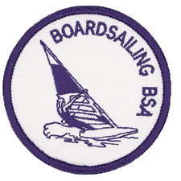

SWIM TRUNKS EMBLEM
The Boardsailing, BSA Patch is NOT worn on the Uniform.
It is worn on the left side of the swim trunks.

Requirements
- Review the BSA guidelines for boardsailing and explain steps you have taken to follow each of the eleven guidelines found in Section V of Camp Program and Property Management, No. 20-920.
- Explain precautions to be taken for boardsailing on each of the following.
  - Lakes
  - Rivers
  - Ocean or bay areas
- What is hypothermia? Describe to your counselor the symptoms of hypothermia. What special considerations in preventing hypothermia are necessary for boardsailing?
- Properly rig and prepare the sailboard you are using. Point out and explain the function of each of the following: uphaul, outhaul, downhaul, cleat, leach, tack, clew, foot, skeg, centerboard, wishbone boom, universal, luff, and center of effort. Explain how to steer the sailboard.
- Demonstrate your ability to uphaul the sail, find the neutral position to the wind (sail luffing), and control the board's position with foot movement.
- With supervision from your instructor, sail a course that involves beating, reaching, and running. Change tack by coming about.

