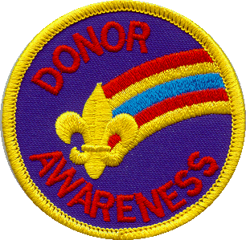

Donor Awareness Patch

For a number of years, BSA has offered to Cub Scouts and Boy Scouts the Donor Awareness Patch shown above. It is worn on the right pocket of the uniform as a temporary insignia. BSA has reduced their emphasis on this program, but has not discontinued it completely. The patch is still being produced, but some Scout Shops™ may not routinely stock the patch. To avoid disappointing Scouts, CHECK FIRST to see if any are available in your area before promoting this program and patch. Of course, promoting Donor Awareness is still a valid project for Scouts, and can be done, even without the opportunity to get this patch.
There are NO formal requirements for these patches. Each Unit establishes the procedure for awarding the strip. Usually, a Donor Awareness Patch is awarded to a Cub Scout or Boy Scout the first time he is successful in getting an adult family member, friend, relative, or other acquaintance to agree to become an organ donor, and to fill out and carry an Organ Donor Card.
Typically, a unit will award only ONE patch to a boy while a member of that unit.

