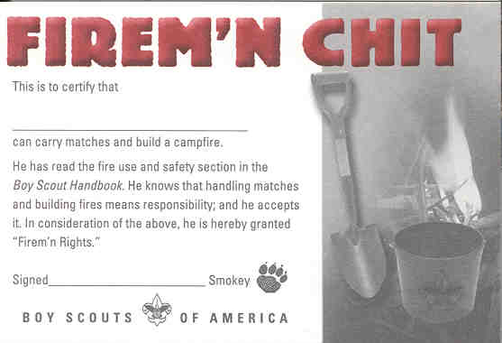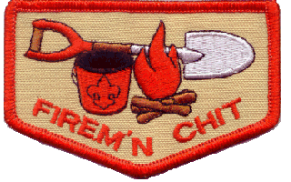

The Firem'n Chit Patch is considered a "Temporary Patch" and, if worn,
should be worn centered on the RIGHT Pocket of the Boy Scout Uniform Shirt.
It should NOT be sewn on a pocket flap

The requirements in Boy Scout Requirements (34765) read as follows:
This certification grants a Scout the right to carry matches and build campfires. The Scout must show his Scout leader, or someone designated by his leader, that he understands his responsibility to do the following:
- Read and understand fire use and safety rules from the Boy Scout Handbook.
- Secure necessary permits (regulations vary by locality).
- Clear all flammable vegetation at least 5 feet in all directions from fire (total 10 feet).
- Attend to fire at all times.
- Keep fire-fighting tools (water and/or shovel) readily available.
- Leave fire when it is cold out.
- Subscribe to the Outdoor Code and Leave-No-Trace.
The Scout's "Firem'n Rights" can be taken from him if he fails in his responsibility.

