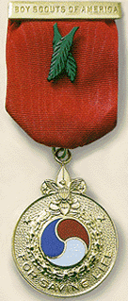 | 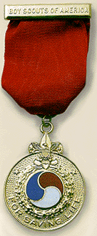 | 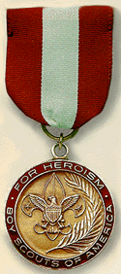 | 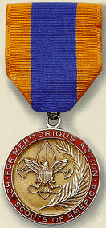

National Court of Honor

Lifesaving and Meritorious Awards

National awards for lifesaving and meritorious acts are made only for outstanding and unusual acts that demonstrate unusual heroism, skill or bravery and reflect Scouting ideals, based on the following criteria:

Honor Medal with Crossed Palms.
- Has demonstrated unusual heroism and extraordinary skill or resourcefulness in saving or attempting to save a life at extreme risk to self.

Honor Medal.
- Has demonstrated unusual heroism and skill or resourcefulness in saving or attempting to save a life at considerable risk to self.

Heroism Award.
- Has demonstrated heroism and skill in averting serious injury or saving or attempting to save a life at minimum risk to self.

Medal of Merit.
- Has performed an act of service of a rare or exceptional character that reflects an uncommon degree of concern for the well-being of others.

National Certificate of Merit.
- Has performed a significant act of service that is deserving of national recognition. Note: If the action is deserving of merit but does not qualify for a national award, the Scout may be eligible for the Local Council Certificate of Merit, No. 33732.

Local Council Certificate of Merit.
- The situation does not meet the criteria for a National Court of Honor award but the act is deserving of recognition. The case is not extraordinary, did not call for unusual skill and was not exceptional in nature but was of outstanding service and did reflect the high ideals of Scouting.
Heroism is defined as conduct exhibiting courage and daring, skill, and self-sacrifice.
Skill is defined as the ability to use one's knowledge effectively in execution or performance. Special attention is given to skills earned in Scouting.
The form for recommending someone for the Medal of Merit, Honor Medal, or Heroism Award, is an 8 page form, BSA Form No 92-104, entitled "Recommendation for Lifesaving or Meritorious Action Awards. It can be downloaded in PDF format from the following location: http://www.tac-bsa.org/lifesaving_meritorious_action_award.pdf and other council web sites. (Try searching for the term "Recommendation for Lifesaving" on Google.)

