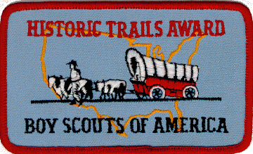

The Historic Trails Award is available as a Cloth or Leather Patch or a Decal. It is NOT worn on the Uniform, but may be attached to equipment, jackets, backpacks, patch vests or blankets, etc.

To Earn this award, members of your unit must plan and participate in a historic activity. A unit historic activity requires members to:
- Locate a historic trail or site and study information relating to it. (The information may be obtained from an adult historic society, public library, or people living near the trail or the site.)
- Hike or camp 2 days and 1 night along the trail or in the vicinity of the site.
- Cooperate with an adult group such as a historic society to restore and mark all or part of this trail or site. (This may be done during the hike or overnight camp.) Or cooperate with such a group to plan and stage a historic pageant, ceremony, or other public event related to this trail or site -- such event should be large enough to merit coverage by the local press.
- Your unit leader must then file the Historic Trails Award application with your council service center.

