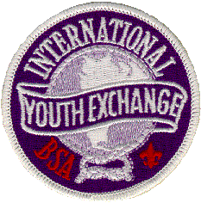

International Youth Exchange Emblem
(For Boy Scouts, Varsity Scouts, Venturers, and Scouters)

The 3-inch International Youth Exchange emblem is worn centered on the right pocket of the uniform shirt. It is a temporary emblem awarded to individuals who complete the following requirements:
- Participate for at least five days in a group exchange program, visiting a Scout group in another nation. This visit can involve home hospitality, joint camping with the host group, or another joint activity.
- Participate for at least five days in a group exchange program, hosting a Scout group from another nation in your community.* This can involve home hospitality, joint camping with the guest group, or another joint activity.
- Plan activities, as both host and guest, that will provide both parties opportunities to learn about each other's countries, cultures, and Scout associations.
- Exchange groups must be at least patrols or crews of six to eight Scouts or Venturers with two adult leaders.
The exchange group must complete all requirements to qualify for recognition. Each individual in the group must complete all requirements to qualify. Certification of an individual for the International Youth Exchange emblem is the responsibility of the unit leader or a designated representative.
Unit representatives may order the emblems (No. ID-214) from the International Division at a cost of $3 (plus state sales tax) per emblem. Please make check or money order payable to the Boy Scouts of America.
International Division, S221
Boy Scouts of America
1325 West Walnut Hill Lane
P.O. Box 152079
Irving, Texas 75015-2079
Phone: 972-580-2401
Fax: 972-580-2413

