Interpreter Strips

UNIFORM INSIGNIA WORN CENTERED ABOVE
"BOY SCOUTS OF AMERICA" STRIP

Youth and Adult members (Cub and Webelos Scouts, Boy and Varsity Scouts, Venturers, and Sea Scouts, plus Scouters in all programs) may wear this strip if they show their knowledge of a foreign language or the sign language for the hearing impaired by:
- Carrying on a 5-minute conversation in this language.
- Translating a 2-minute speech or address.
- Writing a letter in the language (Does not apply for sign language)
- Translating 200 words or more from the written word.

NOTE: The strips shown on this page are a representative sample of some of the languages available. Others can be ordered through the Council Service Center. Older strips were red and white, while newer strips are khaki-tan and red.

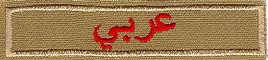 | Arabic
 | Armenian
 | Bengali
 | Cantonese
 | Dutch
 | Finnish
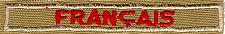 | French
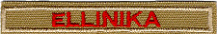 | Greek
 | Hebrew
 | Hebrew
 | Italian
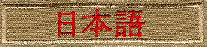 | Japanese
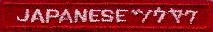 | Japanese Interpretation
 | Korean
 | Korean (in English)
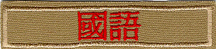 | Mandarin (Traditional)
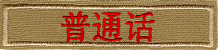 | Mandarin
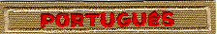 | Portuguese
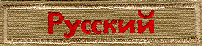 | Russian
 | Signing
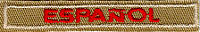 | Spanish
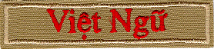 | Vietnamese

