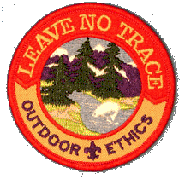

Boy Scout Requirements
- Recite and explain in your own words the principles of Leave No Trace, and discuss how an ethical guideline differs from a rule.
- On three separate camping/backpacking trips with your troop or team, demonstrate and practice the Leave No Trace skills appropriate to the trip.
- Earn the Camping and Environmental Science merit badges.
- Participate in a Leave No Trace-related service project that reduces or rehabilitates recreational impacts. Discuss with your troop or team which recreational impacts were involved with the project.
- Give a 10-minute presentation on a Leave No Trace topic approved by your unit leader to a Scouting unit or other interested group.
- Teach a Leave No Trace-related skill to a Scouting unit or other interested group..

