Survival: Lightning Myths: Busted
Knowing fact from fiction can help you avoid—and survive a 54,000V strike.
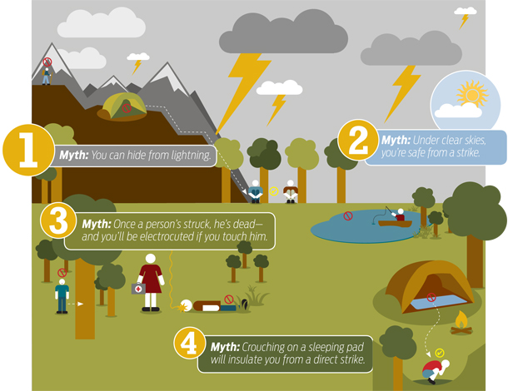
1.)Myth: You can hide from lightning
Busted: No place is 100-percent safe in the backcountry, but some spots are better than others.
Top priority: Get low relative to nearby terrain.
Uniform forests are safest. Avoid open meadows, lakes, caves, rock overhangs, peaks, or ridges.
Best option: Go inside a building or hard-topped car.
2.) Myth: Under clear skies, you’re safe from a strike.
Busted: “Bolts from the blue” can travel and strike as far as 25 miles from storm clouds.
Check regional forecasts. Be alert for storms within 100 miles of your route; watch the direction they’re trending.
You’re within strike range if you can hear thunder. Look for shelter when (or before) thunder and lightning are 30 seconds apart.
Stay under cover until 30 minutes have passed since the last thunderclap.
3.) Myth: Once a person’s struck, he’s dead—and you’ll be electrocuted if you touch him.
Busted: About 90 percent of strike victims survive. After being hit, they can’t shock you—but will likely benefit from first aid.
Administer CPR. Almost all lightning fatalities are due to cardiac arrest. Immediate CPR may restart the heart and save a victim’s life.
Treat wounds. Look for and address head injuries and fractures. Burn first aid: cool with water, apply antibacterial ointment, and bandage.
Immediately evacuate any strike victim to a hospital.

4.) Myth: Crouching on a sleeping pad will insulate you from a direct strike.
Busted: Nothing in the backcountry insulates against a strike or ground current (the most common cause of lightning injury). Reduce exposure to both by assuming a tucked, tight crouch.
Stay low. Short objects are less likely strike targets.
Keep your arms and feet close. Spreading them increases the severity of injuries and burns if you’re struck.
Don’t lie down. Minimize contact with the ground; keep your body’s footprint as small as possible.

What Your Should Know
• Get off peaks early; descend by 2 p.m. in storm season.
• Avoid exposed campsites; tents provide no electrical shelter.
• Stay 50 feet from others.
• Move off lakes and away from tall shoreline trees.
• Flee meadows; even in low terrain the tallest objects attract • strikes.
• Avoid lone tall trees.
• Anticipate nighttime storms; plan a route to safer terrain.
• Safer: ditches and dips.

Interesting Facts
• An average bolt is five miles long, one inch thick, and has • enough energy to power a headlamp for 139,500 years.
• Doh! Guys get struck 4 times as much as gals.
• 5 Seconds it takes for the sound of thunder to travel one mile

Deadliest Wilderness Sports
Whatcha doing when lightning strikes?
Fishing - 25%
Camping - 24%
Swimming -18%
Hiking - 7%

