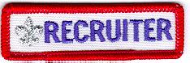

Cub Scouts and Boy Scouts may be awarded, and wear, below the right pocket on their uniforms, the Recruiter Strip shown above
There are NO formal requirements for these strips. Each Unit establishes the procedure for awarding the strip. Usually, a Recruiter Strip is awarded to a Cub Scout or Boy Scout the first time he is successful in getting a friend, relative, classmate, or other acquaintance to join his unit.
Typically, only ONE strip is awarded to a boy while he is a Cub Scout, and another may be awarded while he is a Boy Scout.

