Spirit of the Eagle Award
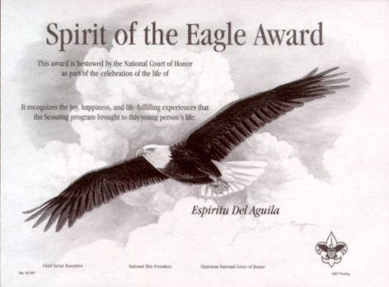

The Boy Scouts of America has created the Spirit of the Eagle Award as an honorary posthumous special recognition for a registered youth member who has lost his or her life in a tragic accident or through illness.
This award is bestowed by the National Court of Honor as part of the celebration of life of this young person. The award recognizes the joy, happiness, and life-fulfilling experiences that the Scouting program made in this person's life.
The guidelines are:
- The recipient must be a registered youth member under 21 years of age at the time of his or her death.
- The unit committee must submit an application for the award within six months of the youth member's death.
- The unit committee must request the approval of the local council.
The Spirit of the Eagle Award application, No. 92-108, is available through local council service centers.

