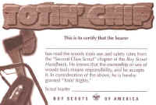 | 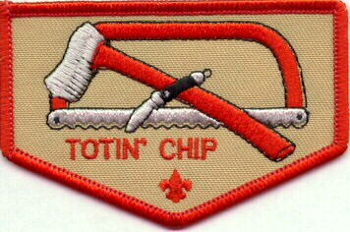

This certification grants a Scout the right to carry and use woods tools. The Scout must show his Scout leader, or someone designated by his leader, that he understands his responsibility to do the following:
- Read and understand woods tools use and safety rules from the Boy Scout Handbook.
- Demonstrate proper handling, care, and use of the pocket knife, ax, and saw.
- Use the knife, ax, and saw as tools, not playthings.
- Respect all safety rules to protect others.
- Respect property. Cut living and dead trees only with permission and with good reason.
- Subscribe to the Outdoor Code.
The Scout's "Totin' Rights" can be taken from him if he fails in his responsibility.

