 |  |  | 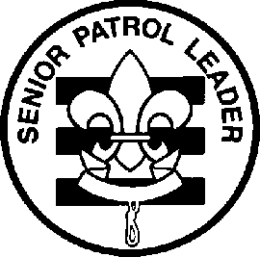
 |  | 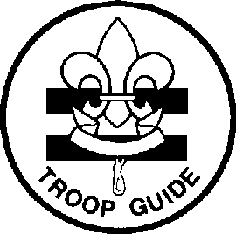 | 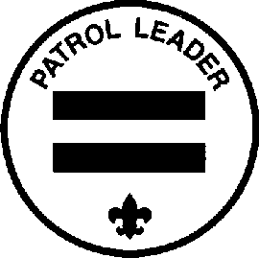 | 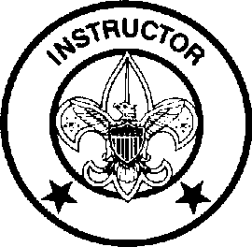 | 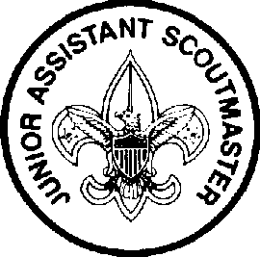
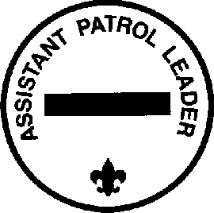 | 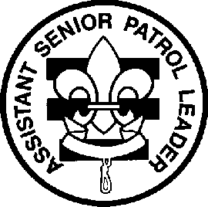 | 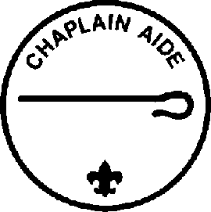 |  | 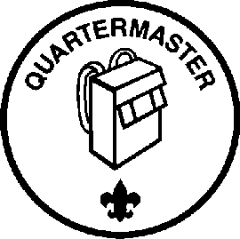 | 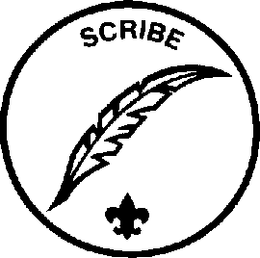 | 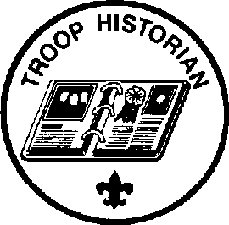

Troop 577 Youth Leadership Positions,
Duties and Responsibilities

(Updated January 2012)

Leading the way...

What does that mean? Think about being a Cub Scout. You came to den meetings and did a lot of different and fun things. But who decided what to do and who planned the activities? The Den Leaders, right? Sports teams are a lot of fun, too. But who decides who plays what position, who's on the starting lineup and when to substitute? The coach, right? There is one thing that makes Scouting different from all other youth groups. Do you know what it is? Well, it is not the uniform. Every soccer, basketball, and baseball team has a uniform. It is not the fun activities. There are a lot of other things that are fun, And it certainly isn't cleaning dirty pots and pans on a campout!!

What makes Scouting special is that YOU make the decisions!

That's right! YOU run the troop. Baden-Powell made it very plain in Aids to Scoutmastership when he wrote,
"The best progress is made in those Troops where power and responsibility are really put into the hands of the Patrol Leaders."

This is real decision making power. And no it's not just Patrol Leaders. All of the troop leadership positions have a hand in making the Troop run. As a troop leader you will:
- Plan and run troop meetings,
- Pick troop outings, where to camp, what to do,
- Plan advancement opportunities for all troop members
- Select High-Adventure programs
- Determine troop policy
- Help other Scouts along the trail to Eagle.

Sound cool? It really is! The adults are there to provide support but YOU will be making the decisions. Because being a leader is more than just sewing on a patch, we have put together job descriptions for the troop leadership positions. They will give you a good idea of what each job is all about and what you will be required to do.
Here's how to be considered for a position. First read the job descriptions, qualifications, and job responsibilities. Then decide what you want to do and talk it over with your parents. You can also talk it over with other Scouts who have served in that position. Finally, get a troop job application form, fill it out, have your parent(s) read and sign it and turn it in.

So, are you ready to "Lead the way"? We sure hope so!

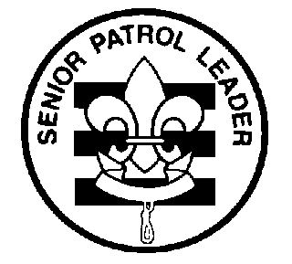

Troop 577
Leadership Position Description

SENIOR PATROL LEADER

GENERAL INFORMATION
Type: Elected by the members of the troop
Term: 6 months
Reports to: Scoutmaster
Description: The Senior Patrol Leader is elected by the Scouts to represent them as the top junior leader in the troop.
Comments: The Senior Patrol Leader is the focal point of the troop. He needs to attend as close to all troop functions as possible. One of the major parts of the SPL's job is to appoint other troop leaders. He must choose leaders who are able, not just his friends or other popular Scouts.

QUALIFICATIONS
Age: none
Rank: 1st Class or higher
Experience: Previous service as SPL, ASPL, PL, or APL
Attendance: 75% over previous 6 months

PERFORMANCE REQUIREMENTS
Training: You must attend the troop Junior Leader Training even if you have attended in the past.
Attendance: You are expected to attend 85% of all troop meetings, Patrol Leaders' Council meetings, outings, and service projects. If your attendance is low, or if you have three (3) unexcused absences in a row, you can be removed from office.
Effort: You are expected to give this job your best effort.

GENERAL LEADERSHIP RESPONSIBILITIES
Uniform: Set the example by wearing your uniform correctly. This means that you will wear all of the parts of the troop uniform, shirt tail tucked in, with all required badges in their correct locations.
Behavior: Set the example by living the Scout Oath and Law in your everyday life. Show Scout Spirit in everything you say and do.
Attendance: Set the example by being an active Scout. Be on-time for meetings and activities. You must call the Scoutmaster if you are not going to be at a meeting or if you suddenly have to miss an outing. You also need to make sure that the Assistant Senior Patrol Leader is ready to assume your responsibilities.

SPECIFIC LEADERSHIP RESPONSIBILITIES
- Runs all troop meetings, events, activities, and the annual program planning conference.
- Runs the Patrol Leader's Council meeting.
- Appoints other troop junior leaders with the advice and counsel of the Scoutmaster.
- Assigns duties and responsibilities to junior leaders.
- Assists the Scoutmaster with Junior Leader Training.

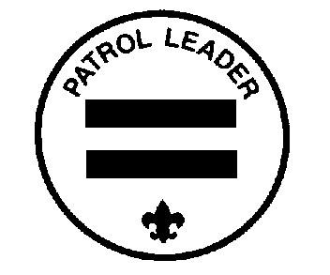

Troop 577
Leadership Position Description

PATROL LEADER

GENERAL INFORMATION
Type: Elected by members of the patrol
Term: 6 months
Reports to: Senior Patrol Leader
Description: The Patrol Leader is the elected leader of his patrol. He represents his patrol on the Patrol Leader's Council.
Comments: The Patrol Leader may easily be the most important job in the troop. He has the closest contact with the patrol members and is in the perfect position to help and guide them. The Patrol Leaders, along with the Senior Patrol Leader and Assistant Senior Patrol Leader are the primary members of the Patrol Leaders' Council.

QUALIFICATIONS
Age: none
Rank: none
Experience: none
Attendance: 75% over previous 6 months

PERFORMANCE REQUIREMENTS
Training: You must attend the troop Junior Leader Training even if you have attended in the past.
Attendance: You are expected to attend 80% of all troop meetings, Patrol Leaders' Council meetings, outings, and service projects. If your attendance is low, or if you have three (3) unexcused absences in a row, you can be removed from office.
Effort: You are expected to give this job your best effort.

GENERAL LEADERSHIP RESPONSIBILITIES
Uniform: Set the example by wearing your uniform correctly. This means that you will wear all of the parts of the troop uniform, shirt tail tucked in, with all required badges in their correct locations.
Behavior: Set the example by living the Scout Oath and Law in your everyday life. Show Scout Spirit in everything you say and do.
Attendance: Set the example by being an active Scout. Be on-time for meetings and activities. You must call the Senior Patrol Leader or Scoutmaster if you are not going to be at a meeting or if you suddenly have to miss an outing. You also need to make sure that the Assistant Patrol Leader is ready to assume your responsibilities.

SPECIFIC LEADERSHIP RESPONSIBILITIES
- Appoints the Assistant Patrol Leader.
- Represents the patrol on the Patrol Leader's Council
- Plans and steers patrol meetings
- Helps Scouts advance
- Acts as the chief recruiter of new Scouts
- Keeps patrol members informed
- Knows what his patrol members and other leaders can do.

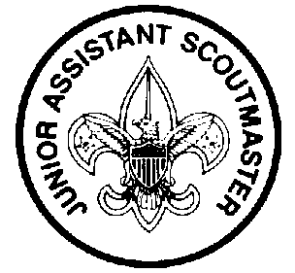
Troop 577
Leadership Position Description

JUNIOR ASSISTANT SCOUTMASTER

GENERAL INFORMATION
Type: Appointed by the Scoutmaster
Term: 1 year
Reports to: Scoutmaster
Description: The Junior Assistant Scoutmaster serves in the capacity of an Assistant Scoutmaster except where legal age and maturity are required. He must be at least 16 years old and not yet 18. He's appointed by the Scoutmaster because of his leadership ability.
Comments: In many cases the JASM has the same responsibilities as an Assistant Scoutmaster.

QUALIFICATIONS
Age: At least 16 years old
Rank: Eagle
Experience: Previous leadership positions
Attendance: 75% over the previous 6 months

PERFORMANCE REQUIREMENTS
Training: You must attend the troop Junior Leader Training even if you have attended in the past.
Attendance: You are expected to attend 80% of all troop meetings, Patrol Leaders' Council meetings, outings, and service projects. If your attendance is low, or if you have three (3) unexcused absences in a row, you can be removed from office.
Effort: You are expected to give this job your best effort.

GENERAL LEADERSHIP RESPONSIBILITIES
Uniform: Set the example by wearing your uniform correctly. This means that you will wear all of the parts of the troop uniform, shirt tail tucked in, with all required badges in their correct locations.
Behavior: Set the example by living the Scout Oath and Law in your everyday life. Show Scout Spirit in everything you say and do.
Attendance: Set the example by being an active Scout. Be on-time for meetings and activities. You must call the Senior Patrol Leader or Scoutmaster if you are not going to be at a meeting or if you suddenly have to miss an outing. You also need to make sure that someone will assume your responsibilities.

SPECIFIC LEADERSHIP RESPONSIBILITIES
- Functions as an Assistant Scoutmaster.
- Performs duties as assigned by the Scoutmaster.

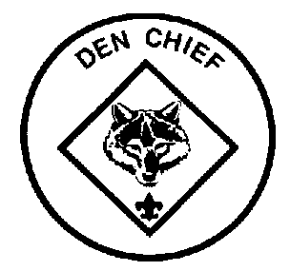
Troop 577
Leadership Position Description

DEN CHIEF

GENERAL INFORMATION
Type: Appointed by the Scoutmaster
Term: 6 months
Reports to: Scoutmaster and Den Leader
Description: The Den Chief works with the Cub Scouts, Webelos Scouts, and Den Leaders in the Cub Scout pack.
Comments: The Den Chief provides a knowledge of games and Scout skills that many Den Leaders lack. The Den Chief is also a recruiter for the troop. This function is important because no troop can thrive without new members and most new members will come from Cub Scouting.

QUALIFICATIONS
Age: 14 or older
Rank: Star or higher
Experience: none
Attendance: 75% over previous 6 months

PERFORMANCE REQUIREMENTS
Training: You must attend the troop Junior Leader Training even if you have attended in the past.
Attendance: You are expected to attend 75% of all troop meetings, Patrol Leaders' Council meetings, outings, and service projects. If your attendance is low, or if you have three (3) unexcused absences in a row, you can be removed from office. In terms of attendance with your den, you are expected to attend 90% of den meetings and pack functions. You must inform the Den Leader if you will be absent.
Effort: You are expected to give this job your best effort.

GENERAL LEADERSHIP RESPONSIBILITIES
Uniform: Set the example by wearing your uniform correctly. This means that you will wear all of the parts of the troop uniform, shirt tail tucked in, with all required badges in their correct locations.
Behavior: Set the example by living the Scout Oath and Law in your everyday life. Show Scout Spirit in everything you say and do.
Attendance: Set the example by being an active Scout. Be on-time for meetings and activities. You must call the Senior Patrol Leader or Scoutmaster if you are not going to be at a meeting or if you suddenly have to miss an outing. You also need to make sure that someone will assume your responsibilities.

SPECIFIC LEADERSHIP RESPONSIBILITIES
- Knows the purposes of Cub Scouting
- Helps Cub Scouts advance through Cub Scout ranks.
- Encourages Cub Scouts to join a Boy Scout troop upon graduation.
- Assists with activities in the den meetings.
- Is a friend to the boys in the den.
- Helps out at weekly den meetings and monthly pack meetings.
- Meets with adult members of the den, pack, and troop as necessary.

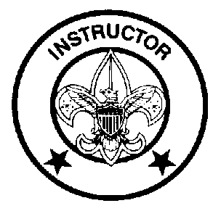
Troop 577
Leadership Position Description

INSTRUCTOR

GENERAL INFORMATION
Type: Appointed by the Scoutmaster
Term: 6 months
Reports to: Scoutmaster
Description: The Instructor teaches Scouting skills.
Comments: The Instructor will work closely with both the Troop Guide and with the Assistant Scoutmaster for new Scouts. The Instructor does not have to be an expert but should be able to teach the Scoutcraft skills needed for Tenderfoot, Second Class, and First Class ranks. The troop can have more than one instructor.

QUALIFICATIONS
Age: 14 or older
Rank: 1st Class or higher
Experience: none
Attendance: 50% over previous 6 months

PERFORMANCE REQUIREMENTS
Training: You must attend the troop Junior Leader Training even if you have attended in the past.
Attendance: You are expected to attend 75% of all troop meetings, Patrol Leaders' Council meetings, outings, and service projects. If your attendance is low, or if you have three (3) unexcused absences in a row, you can be removed from office.
Effort: You are expected to give this job your best effort.

GENERAL LEADERSHIP RESPONSIBILITIES
Uniform: Set the example by wearing your uniform correctly. This means that you will wear all of the parts of the troop uniform, shirt tail tucked in, with all required badges in their correct locations.
Behavior: Set the example by living the Scout Oath and Law in your everyday life. Show Scout Spirit in everything you say and do.
Attendance: Set the example by being an active Scout. Be on-time for meetings and activities. You must call the Senior Patrol Leader or Scoutmaster if you are not going to be at a meeting or if you suddenly have to miss an outing. You also need to make sure that someone will assume your responsibilities.

SPECIFIC LEADERSHIP RESPONSIBILITIES
- Teaches basic Scouting skills in troop and patrols.

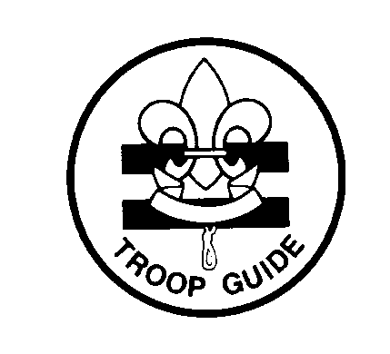
Troop 577
Leadership Position Description

TROOP GUIDE

GENERAL INFORMATION
Type: Appointed by the Scoutmaster
Term: 6 months
Reports to: Scoutmaster
Description: The Troop Guide works with new Scouts. He helps them feel comfortable and earn their First Class rank in their first year.
Comments: The first year as a Boy Scout is a critical time with new places, new people, new rules, and new activities. The Troop Guide is a friend to the new Scouts and makes first year fun and successful. This is an important position.

QUALIFICATIONS
Age: 14 or older
Rank: 1st Class or higher
Experience: none
Attendance: 75% over previous 6 months

PERFORMANCE REQUIREMENTS
Training: You must attend the troop Junior Leader Training even if you have attended in the past.
Attendance: You are expected to attend 90% of all troop meetings, Patrol Leaders' Council meetings, outings, and service projects. If your attendance is low, or if you have three (3) unexcused absences in a row, you can be removed from office.
Effort: You are expected to give this job your best effort.

GENERAL LEADERSHIP RESPONSIBILITIES
Uniform: Set the example by wearing your uniform correctly. This means that you will wear all of the parts of the troop uniform, shirt tail tucked in, with all required badges in their correct locations.
Behavior: Set the example by living the Scout Oath and Law in your everyday life. Show Scout Spirit in everything you say and do.
Attendance: Set the example by being an active Scout. Be on-time for meetings and activities. You must call the Senior Patrol Leader or Scoutmaster if you are not going to be at a meeting or if you suddenly have to miss an outing. You also need to make sure that someone will assume your responsibilities.

SPECIFIC LEADERSHIP RESPONSIBILITIES
- Introduces new Scouts to troop operations.
- Guides new Scouts through early Scouting activities
- Shields new Scouts from harassment by older Scouts.
- Helps new Scouts earn First Class in their first year.
- Teaches basic Scout skills.
- Coaches the patrol leader of the new Scout patrol on his duties.
- Works with the patrol leader at Patrol Leaders' Council meetings.
- Attends Patrol Leaders' Council meetings with the patrol leader of the new Scout patrol.
- Assists the Assistant Scoutmaster with training.
- Counsels individual Scouts on Scouting challenges.

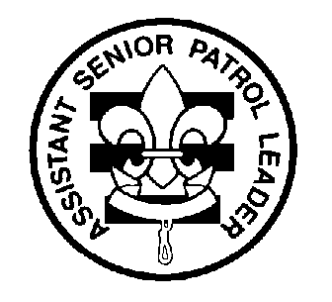
Troop 577
Leadership Position Description

ASSISTANT SENIOR PATROL LEADER

GENERAL INFORMATION
Type: Appointed by the Senior Patrol Leader
Term: 6 months
Reports to: Senior Patrol Leader
Description: The Assistant Senior Patrol Leader is the second highest ranking patrol leader in the troop. The Assistant Senior Patrol Leader acts as the Senior Patrol Leader in the absence of the SPL or when called upon. He also provides leadership to other junior leaders in the troop.
Comments: The most important part of the ASPL position is his work with the other junior leaders. The ASPL should be familiar with the other positions and stay current with the work being done.

QUALIFICATIONS
Age: none
Rank: 1st Class or higher
Experience: none
Attendance: 50% over the previous 6 months

PERFORMANCE REQUIREMENTS
Training: You must attend the troop Junior Leader Training even if you have attended in the past.
Attendance: You are expected to attend 80% of all troop meetings, Patrol Leaders' Council meetings, outings, and service projects. If your attendance is low, or if you have three (3) unexcused absences in a row, you can be removed from office.
Effort: You are expected to give this job your best effort.

GENERAL LEADERSHIP RESPONSIBILITIES
Uniform: Set the example by wearing your uniform correctly. This means that you will wear all of the parts of the troop uniform, shirt tail tucked in, with all required badges in their correct locations.
Behavior: Set the example by living the Scout Oath and Law in your everyday life. Show Scout Spirit in everything you say and do.
Attendance: Set the example by being an active Scout. Be on-time for meetings and activities. You must call the Senior Patrol Leader or Scoutmaster if you are not going to be at a meeting or if you suddenly have to miss an outing. You also need to make sure that someone will assume your responsibilities.

SPECIFIC LEADERSHIP RESPONSIBILITIES
- Helps the Senior Patrol Leader lead meetings and activities.
- Runs the troop in the absence of the Senior Patrol Leader.
- Helps train and supervise the Troop Scribe, Quartermaster, Instructor, Librarian, Historian, and Chaplin Aide.
- Serves as a member of the Patrol Leader's Council.

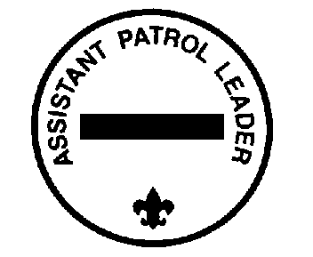
Troop 577
Leadership Position Description

ASSISTANT PATROL LEADER

GENERAL INFORMATION
Type: Appointed by the Patrol Leader
Term: 6 months
Reports to: Patrol Leader
Description: The Assistant Patrol Leader is appointed by the Patrol Leader and leads the patrol in his absence.
Comments: Substituting for the Patrol Leader is only part of the Assistant Patrol Leader's job. The APL actively helps run the patrol.

QUALIFICATIONS
Age: none
Rank: none
Experience: none
Attendance: 50% over previous 6 months

PERFORMANCE REQUIREMENTS
Training: You must attend the troop Junior Leader Training even if you have attended in the past.
Attendance: You are expected to attend 75% of all troop meetings, Patrol Leaders' Council meetings, outings, and service projects. If your attendance is low, or if you have three (3) unexcused absences in a row, you can be removed from office.
Effort: You are expected to give this job your best effort.

GENERAL LEADERSHIP RESPONSIBILITIES
Uniform: Set the example by wearing your uniform correctly. This means that you will wear all of the parts of the troop uniform, shirt tail tucked in, with all required badges in their correct locations.
Behavior: Set the example by living the Scout Oath and Law in your everyday life. Show Scout Spirit in everything you say and do.
Attendance: Set the example by being an active Scout. Be on-time for meetings and activities. You must call the Senior Patrol Leader or Scoutmaster if you are not going to be at a meeting or if you suddenly have to miss an outing. You also need to make sure that someone will assume your responsibilities.

SPECIFIC LEADERSHIP RESPONSIBILITIES
- Helps the Patrol Leader plan and steer patrol meetings and activities.
- Helps the Patrol Leader keep patrol members informed.
- Helps the patrol get ready for all troop activities.
- Represents his patrol at Patrol Leader's Council meetings when the Patrol Leader cannot attend.
- Lends a hand controlling the patrol and building patrol spirit.

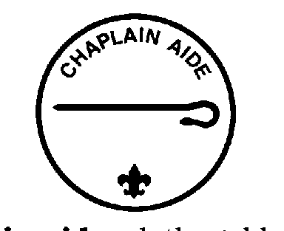
Troop 577
Leadership Position Description

CHAPLIN AIDE

GENERAL INFORMATION
Type: Appointed by the Senior Patrol Leader
Term: 6 months
Reports to: Assistant Senior Patrol Leader
Description: The Chaplin Aide works with the Troop Chaplin to meet the religious needs of Scouts in the troop. He also works to promote the religious awards program.
Comments: "Duty to God" is one of the core beliefs of Scouting. The Chaplin Aide helps everyone in the troop by preparing short religious observations for campouts and other functions. The Chaplin Aide does not always lead the observation himself and can have other troop members help.

QUALIFICATIONS
Age: none
Rank: none
Experience: none
Attendance: 50% over the previous 6 months

PERFORMANCE REQUIREMENTS
Training: You must attend the troop Junior Leader Training even if you have attended in the past.
Attendance: You are expected to attend 60% of all troop meetings, Patrol Leaders' Council meetings, outings, and service projects. If your attendance is low, or if you have three (3) unexcused absences in a row, you can be removed from office.
Effort: You are expected to give this job your best effort.

GENERAL LEADERSHIP RESPONSIBILITIES
Uniform: Set the example by wearing your uniform correctly. This means that you will wear all of the parts of the troop uniform, shirt tail tucked in, with all required badges in their correct locations.
Behavior: Set the example by living the Scout Oath and Law in your everyday life. Show Scout Spirit in everything you say and do.
Attendance: Set the example by being an active Scout. Be on-time for meetings and activities. You must call the Senior Patrol Leader or Scoutmaster if you are not going to be at a meeting or if you suddenly have to miss an outing. You also need to make sure that someone will assume your responsibilities.

SPECIFIC LEADERSHIP RESPONSIBILITIES
- Assists the Troop Chaplin with religious services at troop activities.
- Tells Scouts about the religious emblem program for their faith.
- Makes sure religious holidays are considered during troop program planning.
- Helps plan for religious observance in troop activities.

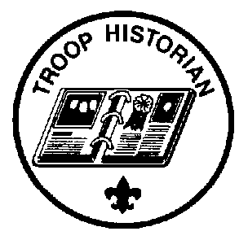
Troop 577
Leadership Position Description

TROOP HISTORIAN

GENERAL INFORMATION
Type: Appointed by the Senior Patrol Leader
Term: 6 months
Reports to: Assistant Senior Patrol Leader
Description: The Troop Historian keeps a historical record or scrapbook of troop activities.
Comments: The true value of a good Historian does not show up until years later. The Historian provides material for displays and presentations of current activities. In addition, the work of the Historian provides a link with the past.

QUALIFICATIONS
Age: none
Rank: none
Experience: none, but interest in photography is helpful
Attendance: 50% over the previous 6 months

PERFORMANCE REQUIREMENTS
Training: You must attend the troop Junior Leader Training even if you have attended in the past.
Attendance: You are expected to attend 60% of all troop meetings, Patrol Leaders' Council meetings, outings, and service projects. If your attendance is low, or if you have three (3) unexcused absences in a row, you can be removed from office.
Effort: You are expected to give this job your best effort.

GENERAL LEADERSHIP RESPONSIBILITIES
Uniform: Set the example by wearing your uniform correctly. This means that you will wear all of the parts of the troop uniform, shirt tail tucked in, with all required badges in their correct locations.
Behavior: Set the example by living the Scout Oath and Law in your everyday life. Show Scout Spirit in everything you say and do.
Attendance: Set the example by being an active Scout. Be on-time for meetings and activities. You must call the Senior Patrol Leader or Scoutmaster if you are not going to be at a meeting or if you suddenly have to miss an outing. You also need to make sure that someone will assume your responsibilities.

SPECIFIC LEADERSHIP RESPONSIBILITIES
- Gathers pictures and facts about past troop activities and keeps them in a historical file or scrapbook.
- Takes care of troop trophies, ribbons, and souvenirs of troop activities.
- Keeps information about former members of the troop.


Troop 577
Leadership Position Description

TROOP LIBRARIAN

GENERAL INFORMATION
Type: Appointed by the Senior Patrol Leader
Term: 6 months
Reports to: Assistant Senior Patrol Leader
Description: The Troop Librarian takes care of troop literature.
Comments: The library contains books of historical value as well as current materials. All together, the library is a troop resource worth hundreds of dollars. The Librarian manages this resource for the troop.

QUALIFICATIONS
Age: none
Rank: none
Experience: none
Attendance: 50% over the previous 6 months

PERFORMANCE REQUIREMENTS
Training: You must attend the troop Junior Leader Training even if you have attended in the past.
Attendance: You are expected to attend 60% of all troop meetings, Patrol Leaders' Council meetings, outings, and service projects. If your attendance is low, or if you have three (3) unexcused absences in a row, you can be removed from office.
Effort: You are expected to give this job your best effort.

GENERAL LEADERSHIP RESPONSIBILITIES
Uniform: Set the example by wearing your uniform correctly. This means that you will wear all of the parts of the troop uniform, shirt tail tucked in, with all required badges in their correct locations.
Behavior: Set the example by living the Scout Oath and Law in your everyday life. Show Scout Spirit in everything you say and do.
Attendance: Set the example by being an active Scout. Be on-time for meetings and activities. You must call the Senior Patrol Leader or Scoutmaster if you are not going to be at a meeting or if you suddenly have to miss an outing. You also need to make sure that someone will assume your responsibilities.

SPECIFIC LEADERSHIP RESPONSIBILITIES
- Sets up and takes care of a troop library
- Keeps records of books and pamphlets owned by the troop.
- Adds new or replacement items as needed.
- Keeps books and pamphlets available for borrowing.
- Keeps a system for checking books and pamphlets in and out.
- Follows up on late returns.
- Issues vouchers for purchase of used merit badge books.

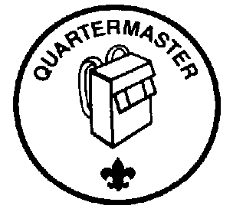
Troop 577
Leadership Position Description

TROOP QUARTERMASTER

GENERAL INFORMATION
Type: Appointed by the Senior Patrol Leader
Term: 6 months
Reports to: Assistant Senior Patrol Leader
Description: The Troop Quartermaster keeps track of troop equipment and sees that it is in good working order.
Comments: The Quartermaster does most of his work around campouts. There are times when the Quartermaster has to be available to check equipment in and out.

QUALIFICATIONS
Age: none
Rank: none
Experience: none
Attendance: 50% over the previous six months

PERFORMANCE REQUIREMENTS
Training: You must attend the troop Junior Leader Training even if you have attended in the past.
Attendance: You are expected to attend 60% of all troop meetings, Patrol Leaders' Council meetings, outings, and service projects. If your attendance is low, or if you have three (3) unexcused absences in a row, you can be removed from office.
Effort: You are expected to give this job your best effort.

GENERAL LEADERSHIP RESPONSIBILITIES
Uniform: Set the example by wearing your uniform correctly. This means that you will wear all of the parts of the troop uniform, shirt tail tucked in, with all required badges in their correct locations.
Behavior: Set the example by living the Scout Oath and Law in your everyday life. Show Scout Spirit in everything you say and do.
Attendance: Set the example by being an active Scout. Be on-time for meetings and activities. You must call the Senior Patrol Leader or Scoutmaster if you are not going to be at a meeting or if you suddenly have to miss an outing. You also need to make sure that someone will assume your responsibilities.

SPECIFIC LEADERSHIP RESPONSIBILITIES
- Keeps records on patrol and troop equipment
- Makes sure equipment is in good working condition
- Issues equipment and makes sure it is returned in good condition
- Makes suggestions for new or replacement items
- Works with the Troop Committee member responsible for equipment
- Gets the US, troop, and patrol flags for meetings and ceremonies and puts them away afterwards.

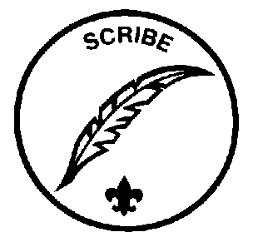
Troop 577
Leadership Position Description

TROOP SCRIBE

GENERAL INFORMATION
Type: Appointed by the Senior Patrol Leader
Term: 6 months
Reports to: Assistant Senior Patrol Leader
Description: The Scribe keeps the troop records. He records the activities of the Patrol Leaders' Council and keeps a record of dues, advancement, and Scout attendance at troop meetings.
Comments: To be a good Scribe you need to attend nearly all troop and Patrol Leaders' Council meetings.

QUALIFICATIONS
Age: none
Rank: none
Experience: none
Attendance: 50% over the previous six months

PERFORMANCE REQUIREMENTS
Training: You must attend the troop Junior Leader Training even if you have attended in the past.
Attendance: You are expected to attend 60% of all troop meetings, Patrol Leaders' Council meetings, outings, and service projects. If your attendance is low, or if you have three (3) unexcused absences in a row, you can be removed from office.
Effort: You are expected to give this job your best effort.

GENERAL LEADERSHIP RESPONSIBILITIES
Uniform: Set the example by wearing your uniform correctly. This means that you will wear all of the parts of the troop uniform, shirt tail tucked in, with all required badges in their correct locations.
Behavior: Set the example by living the Scout Oath and Law in your everyday life. Show Scout Spirit in everything you say and do.
Attendance: Set the example by being an active Scout. Be on-time for meetings and activities. You must call the Senior Patrol Leader or Scoutmaster if you are not going to be at a meeting or if you suddenly have to miss an outing. You also need to make sure that someone will assume your responsibilities.

SPECIFIC LEADERSHIP RESPONSIBILITIES
- Attends and keeps a log of Patrol Leaders' Council meetings
- Records individual Scout attendance and dues payments.
- Records individual Scout advancement progress
- Works with the Troop Committee members responsible for records and finance.

