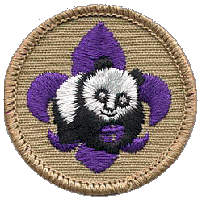

The World Conservation Award is worn on the uniform shirt, centered on the right pocket as a TEMPORARY patch. Only ONE Temporary patch may be worn at a time.

The World Conservation Award provides an opportunity for individual Cub Scouts, Boy Scouts, Varsity Scouts, and Venturers to "think globally" and "act locally" to preserve and improve our environment. This program is designed to make youth members aware that all nations are closely related through natural resources and that we are interdependent with our world environment.
As a Boy Scout, you can earn this award by earning the following merit badges:
- Environmental Science merit badge.
- Soil and Water Conservation or Fish and Wildlife Management merit badge.
- Citizenship in the World merit badge.

