Troop 577
Assistant Senior Patrol Leader
Leadership Guidebook

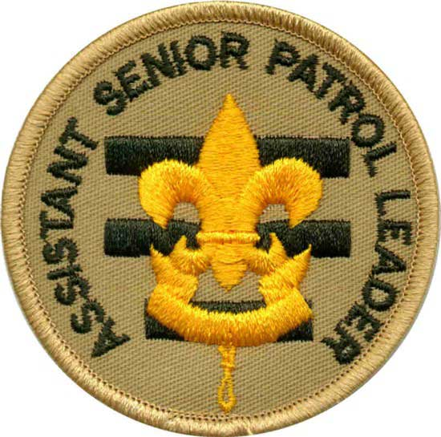

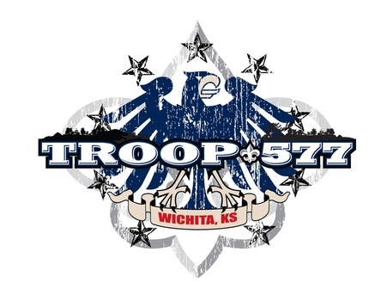
Preface to This Book

Many times adult leaders hear this phrase from boy leaders: "I didn’t know I was supposed to do that." This book is designed to help prevent that phrase from being spoken too often. We hope that it will help you in the performance of your duties and that it is organized so that you can quickly find help. We believe that if you follow the responsibilities listed in this book that you will find your job much easier and more enjoyable, but most of all, that you will be a better leader.

It has taken about six months to write and produce the original version of this Leadership Book and they are continually being updated. We would like your input on what can be done to make this book better for the next Scout that holds this position. Please put your comments on the Feedback Sheet found elsewhere in this book.

You are responsible for the maintenance of this book while you are in possession of it. There will be periodic updates of various documents that you should promptly place in the book in the correct location. If additional materials or document protectors are needed, please see the Scoutmaster. The monetary value of this book is $20.00. If you lose, destroy, or damage this book beyond use you are responsible for its replacement cost. We do expect these books to be used and not left at home gathering dust, so you will not be charged for normal wear and tear.

And this book should be used. We want to see it with you on every Troop activity - meetings, campouts, and other events. It can help to answer the question, "What do I do now?" In addition, there are other resources you can, and should, use: the Handbook, Fieldbook, Merit Badge Books, Junior Leader Handbook, and others. Many of these are found in the Troop library and can be checked out when you need them.

Good luck in your tenure!

Letter to Parents
Dear Parents,

We’re proud to announce that your son was recently selected as our Troop
Assistant Senior Patrol Leader!

This is an important leadership position within our Troop that, if performed properly, will provide your son with experience and credit toward his next rank. We have a number of things we expect from our boys while serving in a leadership position.

We’ve attached an outline of the responsibilities your son now has and we need your help as he learns his new position. Please review the attached sheet with your son and discuss how he can accomplish his new duties. We believe by doing so, you will provide one of the single most important aspects toward your son’s success, your support. We will also be working with your son to ensure he understands his responsibilities. We ask that you sign the Parent’s Agreement below to signify you have done this.

In addition, we’ll provide him assistance as required and feedback on a continual basis. Our goal is to make him a success, so that the Troop can be a success.

During his term in this new position, we also ask that you help him jot down any lessons learned on the enclosed "lessons learned" worksheet. We’ve developed this worksheet to have the Scouts provide us feedback on what works, doesn’t work, and could be done better or maybe in another way, to continue to improve our programs. We believe your son’s honest feedback will enable us to fine tune our programs to ensure we provide quality programs for the boys. We plan to withhold assigning credit to the boys for performing these duties until the feedback sheet is provided to us. Your help in ensuring these sheets are filled out and provided to us is essential.

We look forward to working with you and your son as he assumes his new duties. If you have any questions, please feel free to contact the Assistant Scoutmaster, the Committee Chairman, or me.

Sincerely,

Joby Steele
Scoutmaster

Parent’s Agreement

I have reviewed the job description for Assistant Senior Patrol Leader with my son and understand the commitment he is making. I agree to support him by helping to make him available for meetings and activities, and by providing encouragement at home. He and I both realize that his active involvement in this position is necessary for the smooth operation of Troop 577.

_______________________________
Parent signature

Letter of Commitment

Congratulations on attaining this leadership position. While performing the duties in this position, we hope you will learn and grow in your abilities as a leader. In order to do so, we challenge you to set goals for yourself so that you can be successful in this position.

Success does not come easily; it takes personal commitment and hard work. However, we believe you have what it takes to succeed and plan to work with you to make your term in this position a rewarding experience for you as well as for the other members of your Troop.

Your Troop adult leadership stands committed to provide you the necessary tools (training, guidance, and resources) for success. However, none of these will work without personal commitment on your part.

In order to receive credit for performing in this position, you must use the tools we provide and apply them to your duties. You must fulfill all requirements of the position in order for us to grant you credit toward rank advancement. Failure to show commitment and willingness to perform all duties will result in you not receiving credit during your tenure in this position.

By signing below, you are stating that you have read this letter and accept the terms stated herein.

Printed Name _____________________________

Signature ________________________________

Date Started ______________________________

Date Completed ___________________________

Approved By ______________________________

JOB DESCRIPTION
The assistant senior patrol leader works closely with the senior patrol leader to help the troop move forward and serves as acting senior patrol leader when the senior patrol leader is absent. Among his specific duties, the assistant senior patrol leader trains and provides direction to the troop quartermaster, scribe, historian, librarian, instructors, and Order of the Arrow representative. During his tenure as assistant senior patrol leader he is not a member of a patrol, but he may participate in the high-adventure activities of a Venture patrol. Large troops may have more than one assistant senior patrol leader, each appointed by the senior patrol leader.

INTRODUCTION
Upon accepting the position of Assistant Senior Patrol Leader, you have agreed to provide a service to your Troop. The responsibility should be fun and rewarding. This job description will provide you with some of the things for which you are responsible while serving in this position. The ASPL is elected by the Troop with the approval of the Scoutmaster. If you have any questions, difficulties or suggestions, bring them to the attention of the Senior Patrol Leader (SPL) or an adult leader.

RESPONSIBLE TO
The Senior Patrol Leader

PREREQUISITES
- None specified
- Elected by the Troop

GENERAL DUTIES
- Primary responsibility is to assist the SPL in leading the Scout Troop.
- Make sure the Scouts enjoy a well scheduled and thought out activities program.
- Work directly with the SPL, Scoutmaster (SM), Troop Committee, other adult leaders, and Scouts, as required to make sure Troop 577 provides a well rounded Scout educational program.
- Provide leadership, guidance, and assistance as required to the Troop Quartermaster, Scribe, Librarian, Historian, Chaplain Aide, and Bugler.
- Set a positive example for all other Scouts by following the Scout Oath, Law, Motto, and proudly wearing the correct uniform to all meetings and activities.

SPECIFIC DUTIES
One to two days prior to each weekly Troop meeting:
- Review the month’s schedule to ensure you’re prepared for the meeting.
- Assist the SPL in calling each Patrol Leader and scheduled adult Merit Badge Counselor or other program leader to ensure they are aware of the duty(s), that they are scheduled to do during the upcoming meeting.
- If the SPL cannot make the meeting, you are in charge of the meeting. Also the ASPL will review, with the SPL, the schedule of events to make sure the ASPL is prepared for the upcoming meeting.

The night of weekly Troop meetings:
- Show up at least 10 minutes prior to the meeting’s start time of 7:00pm to help the SPL and PL’s get the meeting area set up.
- Assist SPL and PL in assigning other Scouts to help get the opening ceremony area prepared (flags out, chairs removed, etc.).
- Get with the SPL, Scoutmaster, and other adult leaders prior to the meeting to see if they have any items that need to be brought up to the Scouts during the opening or closing.
- Make sure the Scouts are in patrol lines when calling the meeting to order.
- Ensure the meeting is called to order promptly at 7:00pm.
- Ensure that the meeting is organized and that the rules of the Troop are followed by all Scouts during the meeting.
- If a campout is planned for the following weekend, check with all PL’s to make sure they have planned a menu and made up a duty roster for the weekend. Make sure to review these to be sure duties are spread out between all campers and that the menu is acceptable (not all junk food).
- Remain in the main meeting room area when possible.
- Be sure to check with the Patrol Leaders during the meeting and make sure that you or the SPL help them if needed.
- If you or any of the Patrol Leaders have trouble with any of the Scouts, be sure to help the SPL and Patrol Leader resolve the problems. If the problem(s) continue, report to SM for help if needed.
- Make sure the meeting ends promptly at 8:00pm.
- Ensure that the meeting area(s) are clean and returned to the same or better condition than they were in prior to the Scout meeting.

One to two nights prior to the Patrol Leaders Council (PLC):
- Help the SPL call all Patrol Leaders, Venture Crew Leader, Troop Guide(s), Scoutmaster and other leaders as needed, to remind them of the date, time and location for PLC.
- Spend a few minutes reviewing previous schedules and present month’s themes (if used) and jot down any ideas you may have for the upcoming schedule.
- If the SPL can’t make the meeting, you are in charge.

At the PLC:
- Make sure you have a copy of last schedule as well as the yearly schedule. Also, bring a sheet for the upcoming months that outline the items that make up a nightly list of meeting activities.
- Work with all PL’s and other meeting attendees to put together a schedule for the upcoming month.
- Make sure the proposed schedule includes the month’s theme (if used), camping plans, and other special activities that are listed on the annual calendar or, are received from the SM.
- Ensure the upcoming month’s schedules are typed up; copies are made, and passed out during the last meeting of the month.

Friday nights when preparing to depart for the campouts:
- Make sure all Scouts arrive in uniform for the campout.
- Get the sheet of people signed up for the campout from the SPL, and check the people off as they arrive.
- Help the Quartermaster get some Scouts to help load the Troop trailer.

During the campouts:
- Make sure that upon arriving to the camping area that all Patrols pick a safe camping area (free from broken glass, away from washout area, as flat as possible, etc.).
- Work with the PL’s to make sure all camp sites are set up, to include cooking area, duty roster posted, tents up, personal gear stowed and water collected, before the Scouts have their cracker barrel.
- Make sure that if there are scheduled activities during the campout that all PL’s make sure their members arrive at the activity on time.
- Make sure that all campers act responsibly, safely, and follow the rules of Scouting during the campout.
- Make sure that the Scouts secure water for cleaning the dishes.
- Make sure the Patrols clean up their area after each meal to include, cleaning all dishes, wiping down the table, return all items to the patrol box, and close the patrol box.

At the end of a campout:
- Let the Quartermaster (QM) know if any equipment is missing, broken, or needs to be taken home by a Scout to be dried out or repacked.
- Make sure Patrol boxes and other equipment is clean and packed properly.
- Help the QM load the trailer.
- Help the SPL with policing the camping area.

RESOURCES:
- None listed

AT THE END OF YOUR TENURE IN THIS POSITION:
- Assistant Senior Patrol Leader (ASPL) Job Description
- Make sure you read the Lessons Learned Feedback Sheet contained in this book and provide the Scoutmaster any comments you may have at least 2 weeks before the new elections.
- Plan to spend some time during the next Troop meeting with the Scout who was appointed to replace you. We want you to review with him what you did during your tenure and what worked, didn’t work, and could have been done better. Give him a good turnover to make sure there’s a smooth transfer of duties from you to him.

Lessons Learned
Feedback Sheet

Position: _____________________________________

Name: _________________________________

Date: _________________________

The purpose of this sheet is to provide you a place to jot down any lessons that you learned while serving in this position. What we ask that what you do is during the time that you are in the position, that you keep a record of things that worked, did not work, and any other comments that you may have that could help us improve this package for the next person.

You have assumed a great deal of responsibility by agreeing to perform these duties. A Scouting program can only be a success if we get effective feedback from our members on what works and what could be improved upon.

Please jot down any thoughts you may have and pass them to the Scoutmaster or other adult leader. Thank You.

Troop 577
Scout Responsibilities

INTRODUCTION: In this section are a number of items that discuss what Troop 577 expects of a Scout in terms of his behavior, uniform and participation. These items provide a clear set of expectations for each Scout.

RESPONSIBLE TO: Each Scout is responsible to any, or all, of the following - his Patrol, Patrol Leader, Assistant Patrol Leader, Senior Patrol Leader, Assistant Senior Patrol Leader, other boy leaders, Assistant Scoutmasters, Scoutmaster, and all members of the Troop Committee.

BEHAVIOR: Every Scout is expected to behave appropriately at all Scout functions.

GENERAL: Behavior problems can be either discipline or attitude related. We try to handle most behavior problems within the Troop structure, but there are times when we will contact parents about a problem. These times may include incidents that we feel are too serious to deal with on a Troop level, or repeated occurrences of the same problem. At those times we will contact the Scout’s parents to have them discuss the problem with us. On campouts or other non-meeting events the parents will be called and told to come and take their son home. At Troop meetings the Scout will be given a letter requesting that he not attend any more meetings unless he brings at least one of his parents to discuss the problem with the Scoutmaster. This letter will be followed up by a phone call to the parents. If the problem is deemed serious enough (a fight, for example), the parents will be called immediately to come and get their son. In the most extreme instances, actions will be taken to remove a Scout from Troop 577. The general rules of the Troop are the Scout Law and the Scout Oath. The Scout Oath is: "On my honor, I will do my best: to do my duty to God and my country, to obey the Scout Law, to help other people at all times, to keep myself physically strong, mentally awake, and morally straight." The Scout Law is: "A Scout is: Trustworthy, Loyal, Helpful, Friendly, Courteous, Kind, Obedient, Cheerful, Thrifty, Brave, Clean, and Reverent." (For full explanations of the parts of the Scout Oath and Law, see pages 45-54 in the Boy Scout Handbook.) Beyond that, we also have some behavior guidelines for both meetings and campouts.

AT TROOP MEETINGS: The leadership of Troop 577 tries to provide safe, fun, and educational Troop meetings every week. Every Scout is asked to observe the following for the good of all members:

- Be on time: Troop meetings start promptly at 7:00 PM which means that you are in your patrol line, quiet, and ready to start at that time.
- Participate in every activity offered to you. If you don’t like an activity, you need to contact your Patrol Leader (PL) and let him know so your voice will be heard in the Patrol Leader Council (PLC)
- Be attentive, which means pay attention to the Senior Patrol Leader (SPL), your Patrol Leader, program instructors, and adult leaders.
- Be cooperative. If asked to do something (within reason), do it. If asked not to do something, don’t do it.
- Don’t harass or hassle other Scouts, adult leaders, or instructors.
- Unless you have specific permission, do not touch, use, or take anything that does not belong to you (other people’s stuff).
- Bring only Scout or meeting program related items with you to Troop meetings. Trading cards, toys, games, radios, and other non-Scout related items are not allowed and may be confiscated until the end of the meeting, if they pose a problem

We also must remember that we are guests in the church building and are only permitted in, and allowed to use, certain parts of it. Troop 577 is responsible for the building and any damage to that building and its contents while we are using it/them. All Scouts are expected to adhere to the following rules concerning the church building:
- If you arrive when no adult leaders are present and the building happens to be unlocked, DO NOT ENTER!
- At no time will you be allowed to go around the outside of the building.
- No food or drinks are allowed; they will be taken from you and thrown away.
- If you track mud/dirt into the building please let an adult leader know so that it is cleaned up.
- Horseplay will not be tolerated.
- After each meeting or event make sure to clean/straighten up the room(s) that we used, picking up all trash (ours or not ours) and putting furniture back in its place. No one is allowed to leave the room until the area is policed to the satisfaction of the Senior Patrol Leader and/or the adult leader in charge

ON CAMPING EVENTS: All of the above rules and guidelines apply on camping events with some changes and additions that are camping specific. These include:
- Arrive on time. Help is always needed to load the equipment prior to our departure. Departure times are established in order for the troop to travel safely and arrive at the campsite in a reasonable amount of time. If you are unable to make the departure time please discuss your problem with the Scoutmaster. If we are loaded and ready to go and you are not there at the established time we will leave without you.
- You WILL wear a seat belt at all times while traveling no matter what seat you are in.
- No one is allowed to ride in the back of pickup trucks at any time, in any place, under any circumstances, whatsoever. (Is that clear enough?)
- The driver of the vehicle you are riding in is the dictator of that vehicle. You are a guest in their vehicle and proper behavior is expected. Consumption of food or beverages in someone’s vehicle is at the discretion of the driver, not the son of the driver. Please respect their wishes.
- You WILL be in full uniform (see UNIFORM below) while traveling. If you don’t have one on you will be asked to do so. If you don’t have it with you, you will be asked to go home and get it. If you don’t get back in time see #1. When we are coming home the same procedure applies.
- You will do as you are told by your PL, SPL, other youth leaders, and all adult leaders.
- Troop 577 uses the buddy system. A Scout is not allowed to wander around camp without a buddy. During most campouts your buddy is also your tent-mate. If you need to go somewhere and you don’t have a buddy please see your Patrol Leader, Senior Patrol Leader or an adult leader. DO NOT GO ANYWHERE WITHOUT A BUDDY!
- Each Patrol has a duty roster for campouts. You will do your assigned duties promptly; not at the next meal, or the next day, but at the time that you are assigned. You will not do anything else until your duties are completed.
- Along with #8, you will not get in the way of someone else doing their assigned duty. Therefore, if you are not a cook for a meal, stay out of the cooking area.
- NO FLAMES OF ANY KIND, IN ANY TENT, AT ANY TIME, IN ANY PLACE, UNDER ANY CIRCUMSTANCES, WHATSOEVER!!!!!!!! (Again, clear enough? Unless, of course, you have a death wish and pay the Troop for a replacement tent ahead of time, that is, ahead of your fiery, very gory, horrific, and extremely painful, death..........get it?) This includes matches, cigarette lighters, open candles, candle lanterns, gas lanterns, stoves of any kind, heaters, campfires, etc.
- Quiet times are enforced, usually from 10:00 or 11:00 PM until 6:00 or 7:00 AM. Usually they are enforced by the Troop leadership, but when we are in state or federal parks the rangers may also enforce this. Quiet time means that you are in your tent, asleep. If you are not, you will be warned once, and then sent home. The Troop cannot afford to be kicked out of a camping area because of one boy’s foolishness.
- A Scout’s tent is his home on a campout. Just as you wouldn’t go into someone’s home without knocking or ringing the bell, you don’t enter someone else’s tent without their permission

UNIFORM: All Scouts are expected to wear correct uniforms to all Troop and Patrol events. Correct uniforms, and guidelines for wearing them, are:

- "Field Uniform": Consists of a Scout long or short-sleeved shirt with proper earned insignia (including Merit Badge sash/Order of the Arrow sash), Scout long or short pants or blue jeans/khaki pants or shorts. Optional items are: Scout-type belt, hat or socks. Neckerchief and slide may also be worn during appropriate events, check with the Scoutmaster or SPL if you are unsure if it is needed.
- "Class B": • Consists of the Troop activity t-shirt or any other Scout related t-shirt/sweatshirt (camp t-shirts, Council t-shirts, etc.) and Scout pants/shorts, blue jean pants/shorts or khaki pants/shorts.
- Scouts must wear the field uniform to all Courts of Honor, Boards of Review (see below), all Troop meetings between Labor Day and Memorial Day, while traveling to and from campouts and other events, and to all other events requiring it.
- Scouts must wear either the Class A or the Class B uniform to all Troop meetings between Memorial Day and Labor Day, and to all other Scouting events where the Class A uniform is not required.

PARTICIPATION: Each Scout should participate in as many Troop and Patrol functions as possible. This includes Troop meetings, Patrol meetings, campouts, hikes, civic events, money-making projects, and conservation & service projects. We realize that there are sometimes conflicts with other family, school, church, and sports events but it is to your advantage to be as active as you can be in Scouts. Make it a top priority instead of a secondary one. When you are at a Troop or Patrol event we ask that you be there not only in body, but in mind and spirit as well. We also ask that you do your best at all times to be a team player, thinking of what is best for your Patrol and Troop not just for you. There will be a cold, rainy morning on a campout (we guarantee it) where you are your Patrol’s cook for breakfast. You won’t even want to get out of bed, but no one will eat unless you do. This is where being a team player really counts, doing your part even when you don’t feel like it. (When that morning comes - and it will - please remember to put a smile on your face ... no one likes a grumpy cook!)

Everyone likes the fun events - campouts, hikes, swimming, canoeing, high adventure, etc. - but you really show your stuff on the things that aren’t as much fun - money-making projects, service projects and the like. But a Scout is Helpful, therefore EVERY Scout is expected to participate in money-making projects in equal amounts, since the benefits (new/replacement Troop equipment, badges and awards, and registration costs) are for all Scouts. You should also participate in service and conservation projects because we help others outside the Troop at those times. Every Scout should be faithful in paying dues since that money comes back to him in the form of better program. In addition any Scout who is not sufficiently active may not be registered for the following year unless he shows intent to become more active

SAFETY: The safety of all Scouts in Troop 577 is of primary concern to the Troop leadership. Some safety items have already been mentioned, but there are a couple more: Non-folding sheath knives, fireworks, and martial arts weapons (throwing stars, butterfly knives, nun-chucks, etc.) will not be permitted at any Troop or Patrol functions. In addition, firearms and archery equipment are allowed only at those events specifically scheduled for the use of such items, and even then only under qualified adult supervision. For more information see the Guide to Safe Scouting.

INFORMATION: This section is for items that don’t fit neatly into the categories already listed.
- Scoutmaster Conferences: To have a Scoutmaster Conference, a Scout must have completed all but the last two requirements for the rank he is working on. He must then make a request to the Scoutmaster. Conferences are generally conducted at Troop meetings, but may be held at any other Troop function when there is time.
- Boards of Review: Once a Scout has completed his Scoutmaster Conference he should contact the Advancement Coordinator, to schedule an Advancement Board of Review. Once a date has been determined the Scout is required to be in complete field uniform (including neckerchief and slide), have his Scout Handbook with him and have received sign off on the Scoutmaster Conference. Boards of Review may also be called by the Troop Committee or Advancement Coordinator for Scouts who are not advancing in rank.
- Lost & Found: A lost and found box will be available at the Troop meetings for items lost during Troop activities or meetings. Look there first for any item you may have lost. We will not search for people to match up the lost items. Any items left in the box for more than two months are subject to being thrown away, given away or used as Troop equipment.

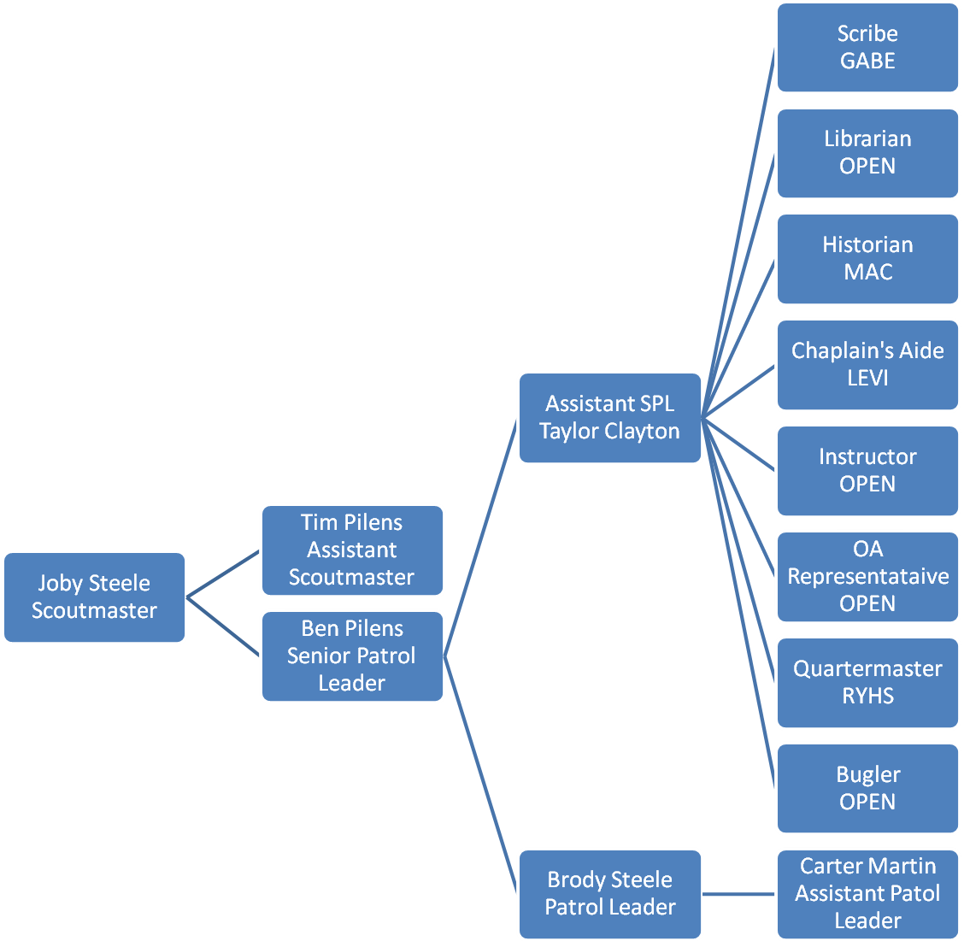

Troop 577 Committee

Mike Martin – Committee Chair
TJ Clayton – Secretary
Tim Pilens – Outdoor Activities Chair
Doug Mann – Webmaster
Joby Steele – Advancement Chair
Rodney Hughes – Treasurer
Mark Borst – Chartered Org Rep
Jeff Whalen – Unit Commissioner
George Steele – Committee Member

POSITION CARD

Assistant Senior Patrol Leader

Be responsible for training ad giving direct leadership to the following appointed Scout leaders: historian, scribe, librarian, quartermaster, and chaplain aide.
Help lead meetings and activities as called upon by the senior patrol leader.
Guide the troop in the senior patrol leader’s absence.
Perform tasks assigned by the senior patrol leader.
Function as a member of the patrol leaders’ council.
Help set and enforce the tone for good Scout behavior within the troop.
Set a good example.
Wear the Scout uniform correctly.
Live by the Scout Oath and Scout law.
Show and help develop Scout spirit.

