Troop 577
Patrol Leader
Leadership Guidebook

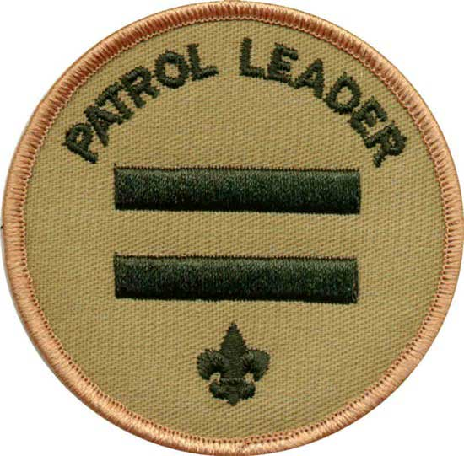

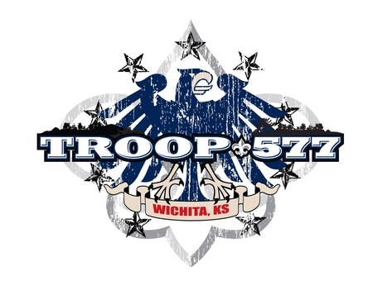

Preface to This Book

Many times adult leaders hear this phrase from boy leaders: "I didn’t know I was supposed to do that." This book is designed to help prevent that phrase from being spoken too often. We hope that it will help you in the performance of your duties and that it is organized so that you can quickly find help. We believe that if you follow the responsibilities listed in this book that you will find your job much easier and more enjoyable, but most of all, that you will be a better leader.

It has taken about six months to write and produce the original version of this Leadership Books and they are continually updated. We would like your input on what can be done to make this book better for the next Scout that holds this position. Please put your comments on the Feedback Sheet found elsewhere in this book.

You are responsible for the maintenance of this book while you are in possession of it. There will be periodic updates of various documents that you should promptly place in the book in the correct location. If additional materials or document protectors are needed, please see the Scoutmaster. The monetary value of this book is $20.00. If you lose, destroy, or damage this book beyond use you are responsible for its replacement cost. We do expect these books to be used and not left at home gathering dust, so you will not be charged for normal wear and tear.

And this book should be used. We want to see it with you on every Troop activity - meetings, campouts, and other events. It can help to answer the question, "What do I do now?" In addition, there are other resources you can, and should, use: the Handbook, Fieldbook, Merit Badge Books, Junior Leader Handbook, and others. Many of these are found in the Troop library and can be checked out when you need them.

Good luck in your tenure!

Letter to Parents
Dear Parents,

We’re proud to announce that your son was recently selected as our Troop
Patrol Leader!

This is an important leadership position within our Troop that, if performed properly, will provide your son with experience and credit toward his next rank. We have a number of things we expect from our boys while serving in a leadership position.

We’ve attached an outline of the responsibilities your son now has and we need your help as he learns his new position. Please review the attached sheet with your son and discuss how he can accomplish his new duties. We believe by doing so, you will provide one of the single most important aspects toward your son’s success, your support. We will also be working with your son to ensure he understands his responsibilities. We ask that you sign the Parent’s Agreement below to signify you have done this.

In addition, we’ll provide him assistance as required and feedback on a continual basis. Our goal is to make him a success, so that the Troop can be a success.

During his term in this new position, we also ask that you help him jot down any lessons learned on the enclosed "lessons learned" worksheet. We’ve developed this worksheet to have the Scouts provide us feedback on what works, doesn’t work, and could be done better or maybe in another way, to continue to improve our programs. We believe your son’s honest feedback will enable us to fine tune our programs to ensure we provide quality programs for the boys. We plan to withhold assigning credit to the boys for performing these duties until the feedback sheet is provided to us. Your help in ensuring these sheets are filled out and provided to us is essential.

We look forward to working with you and your son as he assumes his new duties. If you have any questions, please feel free to contact the Assistant Scoutmaster, the Committee Chairman, or me.

Sincerely,

Joby Steele
Scoutmaster

Parent’s Agreement

I have reviewed the job description for Patrol Leader with my son and understand the commitment he is making. I agree to support him by helping to make him available for meetings and activities, and by providing encouragement at home. He and I both realize that his active involvement in this position is necessary for the smooth operation of Troop 577.

_______________________________
Parent signature

Letter of Commitment

Congratulations on attaining this leadership position. While performing the duties in this position, we hope you will learn and grow in your abilities as a leader. In order to do so, we challenge you to set goals for yourself so that you can be successful in this position.

Success does not come easily; it takes personal commitment and hard work. However, we believe you have what it takes to succeed and plan to work with you to make your term in this position a rewarding experience for you as well as for the other members of your Troop.

Your Troop adult leadership stands committed to provide you the necessary tools (training, guidance, and resources) for success. However, none of these will work without personal commitment on your part.

In order to receive credit for performing in this position, you must use the tools we provide and apply them to your duties. You must fulfill all requirements of the position in order for us to grant you credit toward rank advancement. Failure to show commitment and willingness to perform all duties will result in you not receiving credit during your tenure in this position.

By signing below, you are stating that you have read this letter and accept the terms stated herein.

Printed Name _____________________________

Signature ________________________________

Date Started ______________________________

Date Completed ___________________________

Approved By ______________________________

JOB DESCRIPTION
The patrol leader is the top leader of a patrol. He represents the patrol at all patrol leaders’ council meetings and the annual program planning conference and keeps patrol members informed of decisions made. He plays a key role in planning, leading, and evaluating patrol meetings and activities and prepares the patrol to participate in all troop activities. The patrol leader learns about the abilities of other patrol members and full involves them in patrol and troop activities by assigning them specific tasks and responsibilities. He encourages patrol members to complete advancement requirements and sets a good example by continuing to pursue his own advancement.

INTRODUCTION
Upon accepting the position of Patrol Leader, you have agreed to provide a service to your Patrol and Troop. The responsibility should be fun and rewarding. This job description will provide you with some of the things for which you are responsible while serving in this position. The Patrol Leader is elected by the members of the Patrol. If you have any questions, difficulties or suggestions, bring them to the attention of the Senior Patrol Leader or an adult leader.

RESPONSIBLE TO
The Senior Patrol Leader

PREREQUISITES:
None required

GENERAL DUTIES
- Help the Senior Patrol Leader (SPL) run the Troop by being responsible for your Patrol.
- Take the initiative to lead your Patrol by setting an example for other Scouts and ensuring the members of your Patrol follow the rules of Scouting as well as the specific rules of Troop 577.
- Set a positive example for all other Scouts by following the Scout Oath, Law, Motto, and proudly wearing the correct uniform to all meetings and activities.

SPECIFIC DUTIES
One or two nights prior to each weekly Troop meeting:
- Review the monthly schedule to ensure you’re prepared for the meeting.
- Plan skills instruction for Patrol corners.
- Be sure to call any of your Patrol members to remind them to bring anything special they have to bring to the meeting. Especially important to remind them if they have a skit or ceremony to perform, or campout information.

At the weekly Troop meeting:
- Be sure to show up to the meetings at least 10 minutes early to help get the room ready.
- During the meeting, make sure Patrol members follow all Scouting and Troop 577 rules.
- Review the advancement status of each Patrol member and select items to work on for advancement.

At the Patrol Leaders Conference (PLC):
- Write down and bring ideas, action items, concerns, or problems, you or any member of your Patrol have.
- If you are unable to attend be sure you call the Assistant Patrol Leader (APL) to make sure he will attend for you. Also, give the APL any information you have that will be needed at the PLC.
- Help the other Patrol Leaders and Senior Patrol Leader develop a well planned schedule for the next month.

Monday night before a campout:
- Find out which of your Patrol members are planning to attend the campout, and make a list of them.
- With your Patrol members, make a menu, food and shopping list and appoint food shoppers.
- Make a duty roster (see sample form) for the campout and assign duties to the members in your Patrol.
- If you aren’t going on the campout, make sure your APL has all the information he needs to make the campout successful.

One or two nights before the campout:
- Make sure you have the food required for the campout.
- Be sure to review the month’s schedule to make sure you have any special things your Patrol needs for the campout.
- Check to be sure you have everything needed for the campout.

During the campout:
- Make sure that upon arrival at the camping area that you and your Patrol members pick a safe camping area (free from broken glass, away from washout area, as flat as possible, etc.).
- Work with your Patrol members to make sure your camp site is set up, to include cooking area, duty roster posted, tents up, dining fly or shelter up, personal gear stowed, and water collected, before you begin your Cracker Barrel or other activities.
- Make sure that if there are scheduled activities during the campout that your Patrol members arrive at the activity on time with any needed equipment.
- Make sure that all campers act responsibly, safely, and follow the rules of Scouting during the campout.
- Make sure that the Scouts have prepared hot water for cleaning the dishes.
- Make sure your Patrol members clean up their area after each meal to include: cleaning all dishes, wiping down the table, return all items to the Patrol box, and close the Patrol box.

At the end of a campout:
- Make sure your Patrol box, pots and pans, and utensils are clean.
- Remove any items in the Patrol box that will go bad before it’s used again.
- Inventory your Patrol box to be sure you have an accurate record of what’s in it.
- Report any missing or damaged Patrol box items to the Troop Quartermaster.
- Help put the Troop gear and your Patrol equipment in the trailer.
- Make sure your Patrol cleans up their camping area to remove all trash and debris they may have left behind.
- Take your Patrol Box Inventory with you to the Troop meetings. Do this to help decide what you need to buy for the next campout.

RESOURCES
- None listed

AT THE END OF YOUR TENURE IN THIS POSITION
- Make sure you read the Lessons Learned Feedback Sheet contained in this book and provide the Scoutmaster any comments you may have at least 2 weeks before the new elections.
- Plan to spend some time during the next Troop meeting with the Scout who was elected to replace you. We want you to review with him what you did during your tenure and what worked, didn’t work, and could have been done better. Give him a good turnover to make sure there’s a smooth transfer of duties from you to him.

Lessons Learned
Feedback Sheet

Position: _____________________________________

Name: _________________________________

Date: _________________________

The purpose of this sheet is to provide you a place to jot down any lessons that you learned while serving in this position. What we ask that what you do is during the time that you are in the position, that you keep a record of things that worked, did not work, and any other comments that you may have that could help us improve this package for the next person.

You have assumed a great deal of responsibility by agreeing to perform these duties. A Scouting program can only be a success if we get effective feedback from our members on what works and what could be improved upon.

Please jot down any thoughts you may have and pass them to the Scoutmaster or other adult leader. Thank You.

Troop 577
Scout Responsibilities

INTRODUCTION: In this section are a number of items that discuss what Troop 577 expects of a Scout in terms of his behavior, uniform and participation. These items provide a clear set of expectations for each Scout.

RESPONSIBLE TO: Each Scout is responsible to any, or all, of the following - his Patrol, Patrol Leader, Assistant Patrol Leader, Senior Patrol Leader, Assistant Senior Patrol Leader, other boy leaders, Assistant Scoutmasters, Scoutmaster, and all members of the Troop Committee.

BEHAVIOR: Every Scout is expected to behave appropriately at all Scout functions.

GENERAL: Behavior problems can be either discipline or attitude related. We try to handle most behavior problems within the Troop structure, but there are times when we will contact parents about a problem. These times may include incidents that we feel are too serious to deal with on a Troop level, or repeated occurrences of the same problem. At those times we will contact the Scout’s parents to have them discuss the problem with us. On campouts or other non-meeting events the parents will be called and told to come and take their son home. At Troop meetings the Scout will be given a letter requesting that he not attend any more meetings unless he brings at least one of his parents to discuss the problem with the Scoutmaster. This letter will be followed up by a phone call to the parents. If the problem is deemed serious enough (a fight, for example), the parents will be called immediately to come and get their son. In the most extreme instances, actions will be taken to remove a Scout from Troop 577. The general rules of the Troop are the Scout Law and the Scout Oath. The Scout Oath is: "On my honor, I will do my best: to do my duty to God and my country, to obey the Scout Law, to help other people at all times, to keep myself physically strong, mentally awake, and morally straight." The Scout Law is: "A Scout is: Trustworthy, Loyal, Helpful, Friendly, Courteous, Kind, Obedient, Cheerful, Thrifty, Brave, Clean, and Reverent." (For full explanations of the parts of the Scout Oath and Law, see pages 45-54 in the Boy Scout Handbook.) Beyond that, we also have some behavior guidelines for both meetings and campouts.

AT TROOP MEETINGS: The leadership of Troop 577 tries to provide safe, fun, and educational Troop meetings every week. Every Scout is asked to observe the following for the good of all members:

- Be on time: Troop meetings start promptly at 7:00 PM which means that you are in your patrol line, quiet, and ready to start at that time.
- Participate in every activity offered to you. If you don’t like an activity, you need to contact your Patrol Leader (PL) and let him know so your voice will be heard in the Patrol Leader Council (PLC)
- Be attentive, which means pay attention to the Senior Patrol Leader (SPL), your Patrol Leader, program instructors, and adult leaders.
- Be cooperative. If asked to do something (within reason), do it. If asked not to do something, don’t do it.
- Don’t harass or hassle other Scouts, adult leaders, or instructors.
- Unless you have specific permission, do not touch, use, or take anything that does not belong to you (other people’s stuff).
- Bring only Scout or meeting program related items with you to Troop meetings. Trading cards, toys, games, radios, and other non-Scout related items are not allowed and may be confiscated until the end of the meeting, if they pose a problem

We also must remember that we are guests in the church building and are only permitted in, and allowed to use, certain parts of it. Troop 577 is responsible for the building and any damage to that building and its contents while we are using it/them. All Scouts are expected to adhere to the following rules concerning the church building:
- If you arrive when no adult leaders are present and the building happens to be unlocked, DO NOT ENTER!
- At no time will you be allowed to go around the outside of the building.
- No food or drinks are allowed, they will be taken from you and thrown away.
- If you track mud/dirt into the building please let an adult leader know so that it is cleaned up.
- Horseplay will not be tolerated.
- After each meeting or event make sure to clean/straighten up the room(s) that we used, picking up all trash (ours or not ours) and putting furniture back in its place. No one is allowed to leave the room until the area is policed to the satisfaction of the Senior Patrol Leader and/or the adult leader in charge

ON CAMPING EVENTS: All of the above rules and guidelines apply on camping events with some changes and additions that are camping specific. These include:
- Arrive on time. Help is always needed to load the equipment prior to our departure. Departure times are established in order for the troop to travel safely and arrive at the campsite in a reasonable amount of time. If you are unable to make the departure time please discuss your problem with the Scoutmaster. If we are loaded and ready to go and you are not there at the established time we will leave without you.
- You WILL wear a seat belt at all times while traveling no matter what seat you are in.
- No one is allowed to ride in the back of pickup trucks at any time, in any place, under any circumstances, whatsoever. (Is that clear enough?)
- The driver of the vehicle you are riding in is the dictator of that vehicle. You are a guest in their vehicle and proper behavior is expected. Consumption of food or beverages in someone’s vehicle is at the discretion of the driver, not the son of the driver. Please respect their wishes.
- You WILL be in full uniform (see UNIFORM below) while traveling. If you don’t have one on you will be asked to do so. If you don’t have it with you, you will be asked to go home and get it. If you don’t get back in time see #1. When we are coming home the same procedure applies.
- You will do as you are told by your PL, SPL, other youth leaders, and all adult leaders.
- Troop 577 uses the buddy system. A Scout is not allowed to wander around camp without a buddy. During most campouts your buddy is also your tent-mate. If you need to go somewhere and you don’t have a buddy please see your Patrol Leader, Senior Patrol Leader or an adult leader. DO NOT GO ANYWHERE WITHOUT A BUDDY!
- Each Patrol has a duty roster for campouts. You will do your assigned duties promptly; not at the next meal, or the next day, but at the time that you are assigned. You will not do anything else until your duties are completed.
- Along with #8, you will not get in the way of someone else doing their assigned duty. Therefore, if you are not a cook for a meal, stay out of the cooking area.
- NO FLAMES OF ANY KIND, IN ANY TENT, AT ANY TIME, IN ANY PLACE, UNDER ANY CIRCUMSTANCES, WHATSOEVER!!!!!!!! (Again, clear enough? Unless, of course, you have a death wish and pay the Troop for a replacement tent ahead of time, that is, ahead of your fiery, very gory, horrific, and extremely painful, death..........get it?) This includes matches, cigarette lighters, open candles, candle lanterns, gas lanterns, stoves of any kind, heaters, campfires, etc.
- Quiet times are enforced, usually from 10:00 or 11:00 PM until 6:00 or 7:00 AM. Usually they are enforced by the Troop leadership, but when we are in state or federal parks the rangers may also enforce this. Quiet time means that you are in your tent, asleep. If you are not, you will be warned once, and then sent home. The Troop cannot afford to be kicked out of a camping area because of one boy’s foolishness.
- A Scout’s tent is his home on a campout. Just as you wouldn’t go into someone’s home without knocking or ringing the bell, you don’t enter someone else’s tent without their permission

UNIFORM: All Scouts are expected to wear correct uniforms to all Troop and Patrol events. Correct uniforms, and guidelines for wearing them, are:

- "Field Uniform": Consists of a Scout long or short-sleeved shirt with proper earned insignia (including Merit Badge sash/Order of the Arrow sash), Scout long or short pants or blue jeans/khaki pants or shorts. Optional items are: Scout-type belt, hat or socks. Neckerchief and slide may also be worn during appropriate events, check with the Scoutmaster or SPL if you are unsure if it is needed.
- "Class B": • Consists of the Troop activity t-shirt or any other Scout related t-shirt/sweatshirt (camp t-shirts, Council t-shirts, etc.) and Scout pants/shorts, blue jean pants/shorts or khaki pants/shorts.
- Scouts must wear the field uniform to all Courts of Honor, Boards of Review (see below), all Troop meetings between Labor Day and Memorial Day, while traveling to and from campouts and other events, and to all other events requiring it.
- Scouts must wear either the Class A or the Class B uniform to all Troop meetings between Memorial Day and Labor Day, and to all other Scouting events where the Class A uniform is not required.

PARTICIPATION: Each Scout should participate in as many Troop and Patrol functions as possible. This includes Troop meetings, Patrol meetings, campouts, hikes, civic events, money-making projects, and conservation & service projects. We realize that there are sometimes conflicts with other family, school, church, and sports events but it is to your advantage to be as active as you can be in Scouts. Make it a top priority instead of a secondary one. When you are at a Troop or Patrol event we ask that you be there not only in body, but in mind and spirit as well. We also ask that you do your best at all times to be a team player, thinking of what is best for your Patrol and Troop not just for you. There will be a cold, rainy morning on a campout (we guarantee it) where you are your Patrol’s cook for breakfast. You won’t even want to get out of bed, but no one will eat unless you do. This is where being a team player really counts, doing your part even when you don’t feel like it. (When that morning comes - and it will - please remember to put a smile on your face ... no one likes a grumpy cook!)

Everyone likes the fun events - campouts, hikes, swimming, canoeing, high adventure, etc. - but you really show your stuff on the things that aren’t as much fun - money-making projects, service projects and the like. But a Scout is Helpful, therefore EVERY Scout is expected to participate in money-making projects in equal amounts, since the benefits(new/replacement Troop equipment, badges and awards, and registration costs) are for all Scouts. You should also participate in service and conservation projects because we help others outside the Troop at those times. Every Scout should be faithful in paying dues since that money comes back to him in the form of better program. In addition any Scout who is not sufficiently active may not be registered for the following year unless he shows intent to become more active

SAFETY: The safety of all Scouts in Troop 577 is of primary concern to the Troop leadership. Some safety items have already been mentioned, but there are a couple more: Non-folding sheath knives, fireworks, and martial arts weapons (throwing stars, butterfly knives, nun-chucks, etc.) will not be permitted at any Troop or Patrol functions. In addition, firearms and archery equipment are allowed only at those events specifically scheduled for the use of such items, and even then only under qualified adult supervision. For more information see the Guide to Safe Scouting.

INFORMATION: This section is for items that don’t fit neatly into the categories already listed.
- Scoutmaster Conferences: To have a Scoutmaster Conference, a Scout must have completed all but the last two requirements for the rank he is working on. He must then make a request to the Scoutmaster. Conferences are generally conducted at Troop meetings, but may be held at any other Troop function when there is time.
- Boards of Review: Once a Scout has completed his Scoutmaster Conference he should contact the Advancement Coordinator, to schedule an Advancement Board of Review. Once a date has been determined the Scout is required to be in complete field uniform (including neckerchief and slide), have his Scout Handbook with him and have received sign off on the Scoutmaster Conference. Boards of Review may also be called by the Troop Committee or Advancement Coordinator for Scouts who are not advancing in rank.
- Lost & Found: A lost and found box will be available at the Troop meetings for items lost during Troop activities or meetings. Look there first for any item you may have lost. We will not search for people to match up the lost items. Any items left in the box for more than two months are subject to being thrown away, given away or used as Troop equipment.

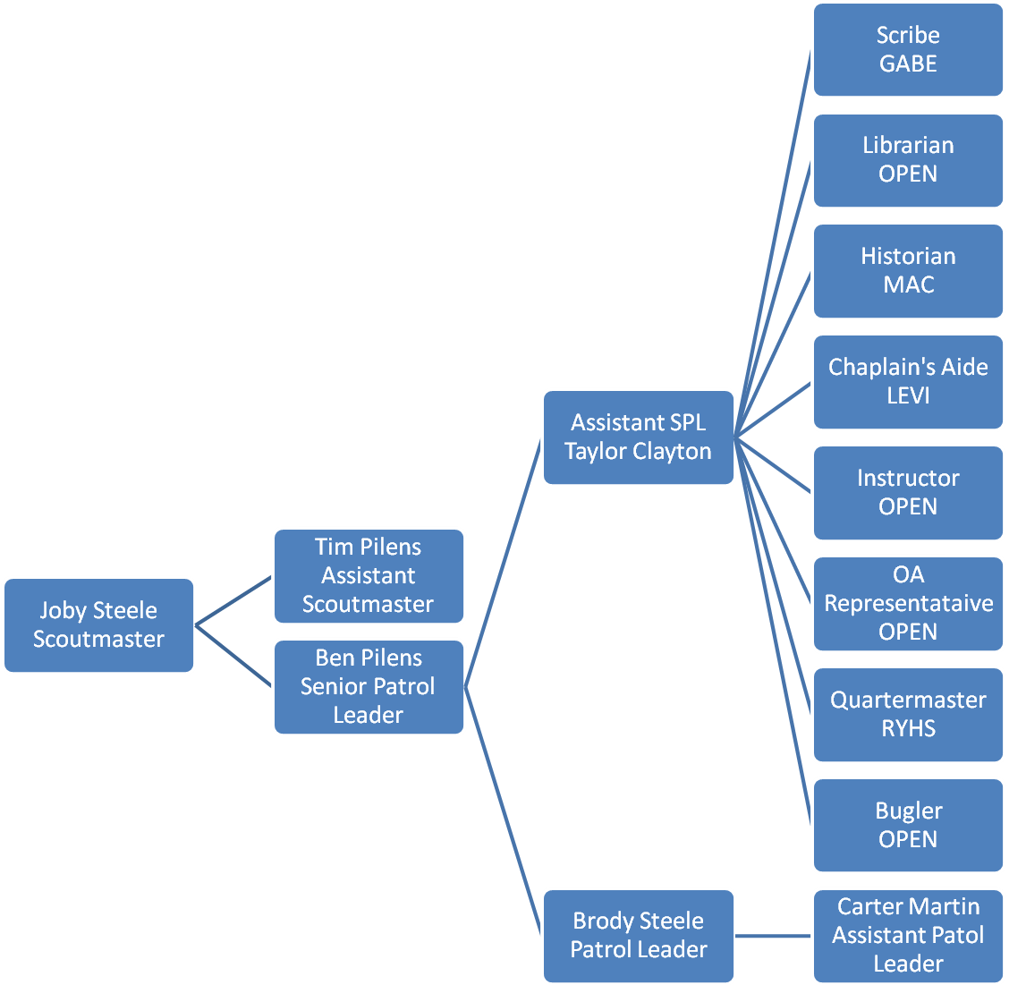
Troop 577 Committee

Mike Martin – Committee Chair
TJ Clayton – Secretary
Tim Pilens – Outdoor Activities Chair
Doug Mann – Webmaster
Joby Steele – Advancement Chair
Rodney Hughes – Treasurer
Mark Borst – Chartered Org Rep
Jeff Whalen – Unit Commissioner
George Steele – Committee Member

POSITION CARD

Patrol Leader

Plan and lead patrol meetings and activities.
Keep patrol members informed.
Assign each patrol member needed tasks and help them succeed.
Represent the patrol at all patrol leaders’ council meetings and the annual program planning conference.
Prepare the patrol to take part in all troop activities.
Show and help develop patrol spirit.
Work with other troop leaders to make the troop run well.
Know what patrol members and other leaders can do.
Set a good example.
Wear the Scout uniform correctly.
Live by the Scout Oath and Scout law.

